NAME: SANTHOSH D
REG NO: (192412209)
COURSE NAME: ANALOG AND DIGITAL COMMUNICATION (ECA0802)
EX NO: 2a
GENERATION AND ANALYSIS OF FREQUENCY MODULATED
(FM) SIGNALS USING MATLAB
Objectives
(i) To generate a Frequency Modulated (FM) signal using MATLAB by varying the frequency of
a high-frequency carrier in accordance with the amplitude of the message signal and to observe
the resulting waveform in the time domain.
(ii) To analyze the frequency spectrum of the generated FM signal using FFT and identify the
carrier component, sideband frequencies, and the bandwidth of the FM signal based on Carson's
rule.
Objective 1: To generate a Frequency Modulated (FM) signal using MATLAB by varying the
frequency of a high-frequency carrier in accordance with the amplitude of the message signal
and to observe the resulting waveform in the time domain.
PROGRAM (MATLAB CODE)
clc;
clear;
close all;
Am=1;
Ac=1;
fm=5;
fc=50;
beta=5;
kp=5;
fs=1000;
t=0:1/fs:1;
m = Am*cos(2*pi*fm*t);
c = Ac*cos(2*pi*fc*t);
% Message signal
% Carrier signal
fm_sig = Ac*cos(2*pi*fc*t + beta*sin(2*pi*fm*t)); % FM
subplot(4,1,1), plot(t,m), title('Message Signal')
subplot(4,1,2), plot(t,c), title('Carrier Signal')
subplot(4,1,3), plot(t,fm_sig), title('FM Signal')

OUTPUT:

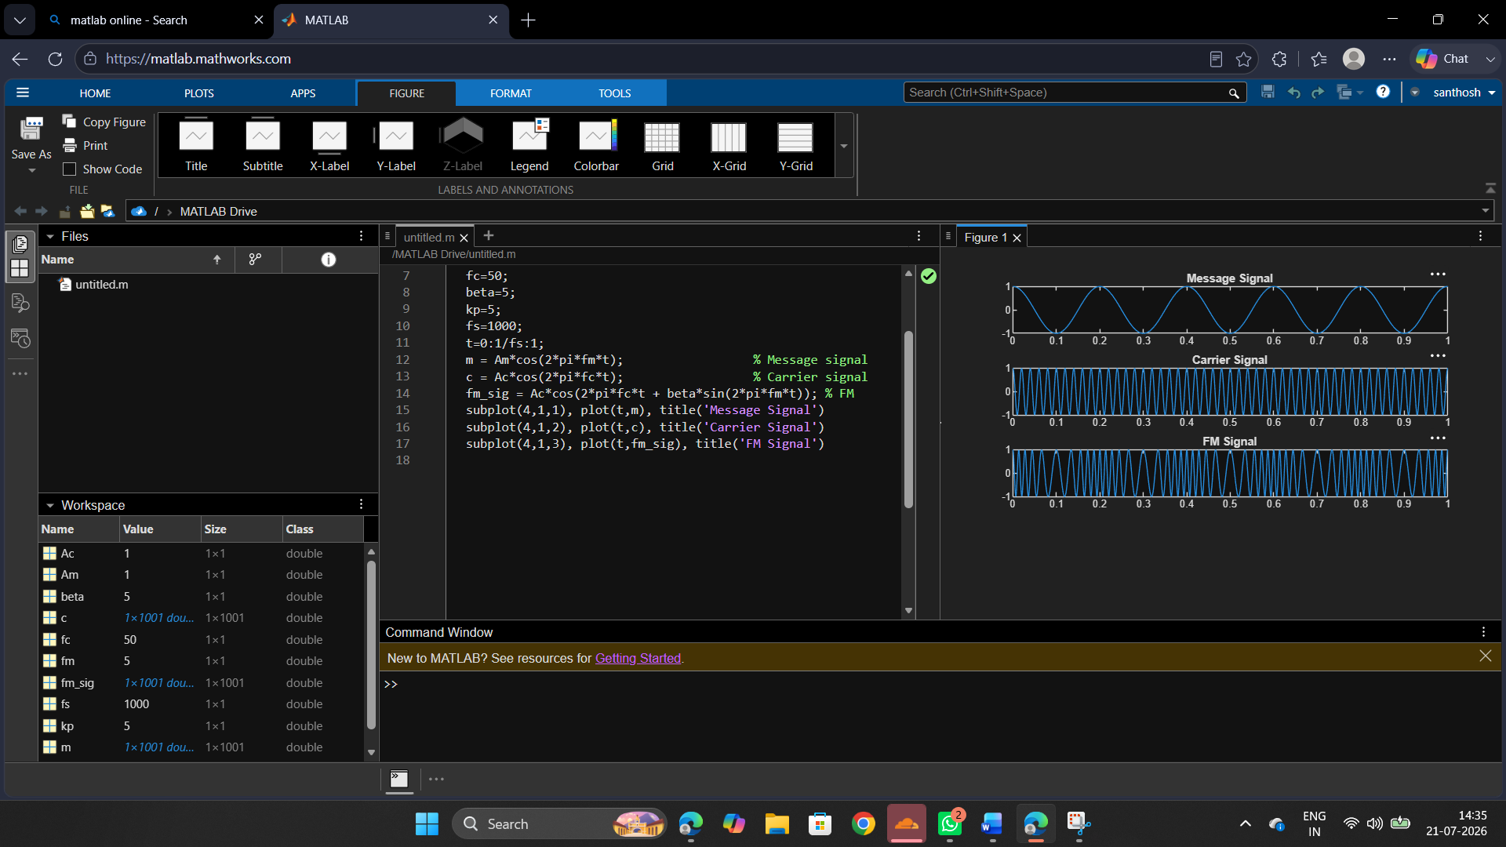

Objective 2: To analyze the frequency spectrum of the generated FM signal using FFT and
identify the carrier component, sideband frequencies, and the bandwidth of the FM signal based
on Carson's rule
PROGRAM (MATLAB CODE)
% Calculation and Verification of Frequency Deviation
% and Modulation Index of FM Signals
clc;
clear;
close all;
%% Input Parameters
Am = 2;
% Message signal amplitude
fm = 500;
Ac = 1;
fc = 10000;
kf = 1000;
fs = 100000;
T = 0.02;
t = 0:1/fs:T;
% Message frequency (Hz)
% Carrier amplitude
% Carrier frequency (Hz)
% Frequency sensitivity (Hz/V)
% Sampling frequency (Hz)
% Simulation duration (s)
%% Message Signal
m = Am*cos(2*pi*fm*t);
%% Frequency Deviation Calculation
delta_f = kf * Am;
%% Modulation Index Calculation
beta = delta_f/fm;
%% FM Signal Generation
fm_signal = Ac*cos(2*pi*fc*t + beta*sin(2*pi*fm*t));
%% Plot Message Signal
figure;
subplot(2,1,1);
plot(t,m,'LineWidth',1.5);
title('Message Signal');
xlabel('Time (s)');
ylabel('Amplitude');
grid on;
%% Plot FM Signal
subplot(2,1,2);
plot(t,fm_signal,'LineWidth',1.5);
title('Frequency Modulated Signal');
xlabel('Time (s)');
ylabel('Amplitude');
grid on;
%% Spectrum Analysis
N = length(fm_signal);
FM_fft = fftshift(abs(fft(fm_signal))/N);
f = (-N/2:N/2-1)*(fs/N);
figure;
plot(f,FM_fft,'LineWidth',1.5);
title('FM Signal Spectrum');
xlabel('Frequency (Hz)');
ylabel('Magnitude');
grid on;
xlim([fc-10000 fc+10000]);
%% Display Results
fprintf('\nFM SIGNAL PARAMETERS\n');
fprintf('---------------------------\n');
fprintf('Carrier Frequency
= %.0f Hz\n',fc);
fprintf('Message Frequency
fprintf('Message Amplitude
= %.0f Hz\n',fm);
= %.2f V\n',Am);
fprintf('Frequency Sensitivity = %.0f Hz/V\n',kf);
fprintf('\nCALCULATED VALUES\n');
fprintf('---------------------------\n');
fprintf('Frequency Deviation (Δf) = %.0f Hz\n',delta_f);
fprintf('Modulation Index (β) = %.2f\n',beta);
%% Carson's Rule Bandwidth
BW = 2*(delta_f + fm);
fprintf('Bandwidth (Carson Rule) = %.0f Hz\n',BW);

OUTPUT:
